**VIETNAM NATIONAL UNIVERSITY, HO CHI MINH CITY**

**HO CHI MINH CITY UNIVERSITY OF TECHNOLOGY**

**OFFICE FOR INTERNATIONAL STUDY PROGRAMS**

**FACULTY OF TRANSPORTATION**

**Bachelor Project**

**Study on the aligning moment acting on the Ackerman   
steering mechanism**

**Instructor: Ngô Đắc Việt**

**Class:** TR4091 – CC01

**Name: Hồ Bình Minh**

**Student ID: 1852169**

December 19th, 2022, Ho Chi Minh City, Vietnam

**🙦 Semester 221**

CONTENTS

**No table of contents entries found.**

**I/ Introduction:**

1. **Objective:**

During the past ten years, EPS has been introduced in gradually increasing numbers. Although electric power steering system offer significant advantages over their hydraulic counterparts, electric motor technology and controls had not reached the point where they could be used in this application until just recently. Electrically assisted power steering is replacing the traditional hydraulic system where the pressure is provided via a pump driven by the vehicles engine. The hydraulic system is constantly running and by using the EPS the fuel consumption can be reduced. In electric and hybrid vehicles, the engine does not run continuously so electric power steering is the only possible solution.

The focus of this project is that we can get a deep analyze as much as possible about this steering system dynamics and its dependence on the difference of forces.

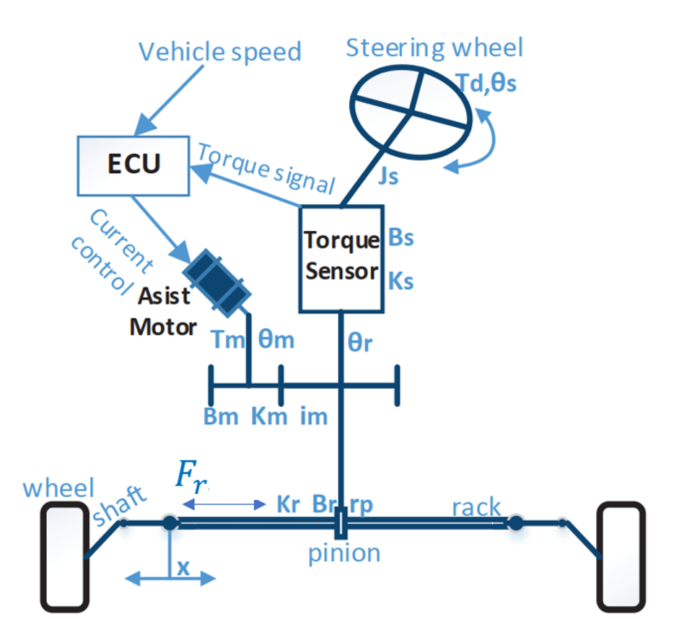

Figure 1: Electric Power Steering system structure

1. **Scope of implementation:**

The model is developed to present vehicle behaviour when driving in normal condition of roads and cars, so it can not be reliable in non-linear conditions (When the vehicle is driven up to its limits). The model developed in this project does not represent the steering condition in parking situations. The model is developed by assuming that the wheels are in contact with the road surface. So, the wheel lift phenomenon is assumed negligible in this model. Besides, the aligning torque that acting on the wheel withstands a lot of types of force: normal force, longitudinal force, lateral force, etc and wheel alignment angle: kingpin angle, caster angle, camber angle, etc but in this project, this aligning torque is only going to be considered in the effect of the lateral force with the specific wheel alignment. There are a lot steering mechanism that follow the Ackerman condition but in this project, I will consider the effect of the aligning moment on the Electric Power Steering system that has the rack and pinion steering mechanism.

1. **Working condition:**

Continuously change to adapt with variable driving conditions.

1. **Technical requirement:**

Working normally in above condition.

Control the speed of the assist motor follows the desired torque in different speed ranges

**II/ Theoretical basics:**

* 1. **General Steering Dynamics Theory:**
     1. **Coordinate systems**:

In the following section, the basic concepts of the coordinate systems used in this project will be presented. In this model, the ISO coordinate systems are used. They are based on the seven coordinate systems as following:

* Earth (X, Y, Z)

The global coordinate system describes the entire environment of the model. It is used as the position reference for the vehicle because of the global coordinate system which does not move

* Vehicle (x, y, z)

The Center of Gravity (COG) coordinate system describes the position of COG

during simulation. In this coordinate system, the x-axis is parallel to the longitudinal movement of the vehicle and points to the front of the vehicle. The yaxis is parallel to the lateral movement of the vehicle and the Z axis is parallel to the vertical movement of the vehicle.

* Wheel (xw, yw, zw)

The wheel coordinate system is in the center of each wheel. In this coordinate system, the x-axis points to the heading of the wheel.

* Path (xp, yp, zp)

The velocity coordinate system is fixed to the center of gravity of the vehicle. The difference of the center of gravity positions follows the velocity vector of the

vehicle such as: longitudinal velocity (in x axis direction), Lateral velocity (in y axis direction), vertical velocity (in z axis direction)

* Yaw (ψ)

Yaw is the rotation around the vertical axis (z-axis) through the center of gravity of the vehicle. The yaw can be felt in skidding or spin movement.

* Pitch (φ)

Pitch is the rotation around the lateral axis (y-axis) through the center of gravity of the vehicle. It can be felt in acceleration or braking movement around (y-axis) of vehicle.

* Roll (ϴ)

Roll is the rotation around the longitudinal axis (x-axis) through the center of gravity of the vehicle. This rotation can be felt during lateral acceleration (side-to-side movement) of the vehicle.

The overall scheme of ISO coordinate system is shown in Figure 2.1.

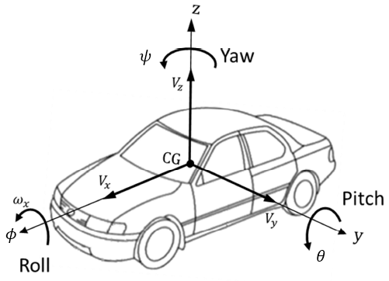

Figure 2.1.1: Overall scheme of ISO coordinate system for vehicle

* + 1. **: Model terminology**

In this part, vehicle dynamics terminology used in this project is shown in Figure 2.2 and described respectively

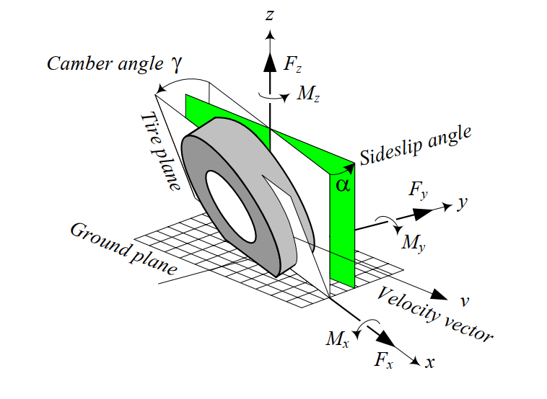 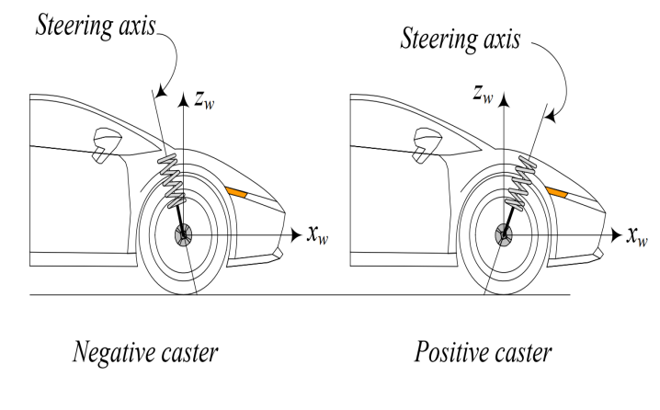

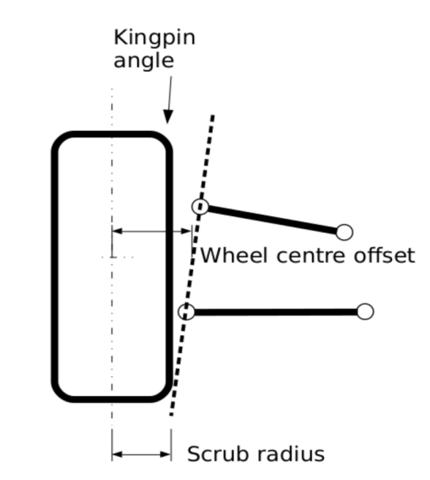

Figure 2.1.2: Vehicle dynamics terminology used in this project

As we can see in Figure 2.2, the tire is the main component interacting with the road. The performance of a vehicle is mainly influenced by the characteristics of its tires. Tires affect a vehicle’s handling, traction, ride comfort, and fuel consumption. To understand its importance, it is enough to remember that a vehicle can maneuver only by longitudinal, vertical, and lateral force systems generated under the tires. Steering process mainly depend on the interaction between below forces, moment, angles:

* Normal force it is vertical force, normal to the ground plane. The resultant normal force > 0 if it is upward. Normal force is also called the vertical force or wheel load.
* Longitudinal force : It is a force acting along the x-axis. The resultant longitudinal force > 0 if the car is accelerating, and < 0 if the car is braking. Longitudinal force is also called forward force.
* Lateral force It is a force, tangent to the ground and orthogonal to both and . The resultant lateral force > 0 if it is in the y direction.
* Yaw moment It is an upward moment about the z-axis. The resultant yaw moment Mz > 0 if it tends to turn the tire about the z-axis. The yaw moment is also called the *aligning moment, self -aligning moment, or bore torque*.
* Side-slip angle is the angle between the velocity vector *v* and the *x*-axis measured about the z-axis. This angle has a big influence on the steering because it directly affects on the magnitude of the lateral force
* Caster angle is the angle to which the steering pivot axis is tilted forward or rearward from vertical, as viewed from the Figure 3. This is one of the most important factors that effects on the aligning torque .
* Kingpin angle is the angle between the kingpin axis and the vertical axis  
  of the tire. The kingpin axis is the line between the lower and upper ball joints of the wheel’s hub
  1. **Steering System Modeling and Wheel Placement Angle theory:**

In this chapter, the steering system used in this thesis is described. As mentioned before, steering system modeling is one of the most important issues in driving simulation. The high fidelity of steering system simulation is useful to achieve high reality steering feel for the driver during driving simulation. The steering system modeled during this project consists of two main parts: steering geometry and steering wheel feedback torque. Steering geometry is created to transmit the steering wheel angle applied by the driver as an input to virtual wheels angles as output. Steering wheel feedback torque has the main purpose of transmitting the torque created in a tire (self-aligning torque, friction torque…) to the steering wheel. In other words, steering system model receives the steering wheel position which is applied by the driver as input and provides the steering wheel feedback torque as output. Besides, wheel placement angle that are necessary for only this project will also be mentioned in this chapter.

* + 1. **Steering system overview:**

The steering system transfers the steering wheel angle to the wheels through a mechanical system composed by a series of rods and pivots linkages. In this case when the driver turns the steering wheel, the steering wheel’s rotation is transmitted through the steering column (steering shaft) to the pinion, the pinion converts the rotation to the linear displacement through the rack and pinion. The created linear movement is transferred to the uprights through the tie roads. The created linear movement at upright generates the steering angle in the wheels. The steering mechanism between the steering box and the steering angle in the wheels presents a transmission rate which is called steering ratio. It is important to notice that the steering wheel angle and wheel angle relates via a steering ratio coefficient. Rack and pinion steering system is commonly used in conventional cars. In this project, the power steering assistance system is used as well as the rack and pinion system. A power steering assist system helps drivers by decreasing the driver’s effort in the steering wheel. The power steering assistance system is comprised of a DC motor and a control unit, so that the control unit calculates if a steering assistance is required for the driver. The rack and pinion steering system is shown in Figure 2.2.1.1 and steering box is shown in Figure 2.2.1.2 respectively.

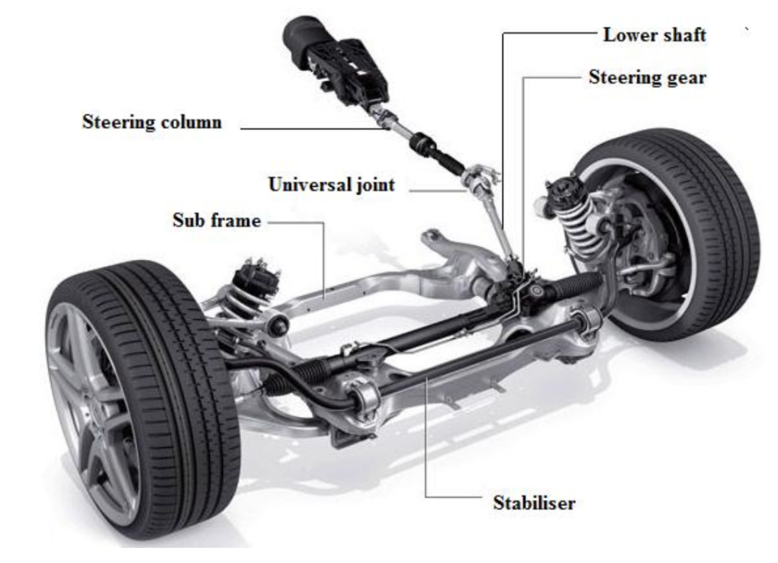

Figure 2.2.1.1: Steering systems (rack and pinion)

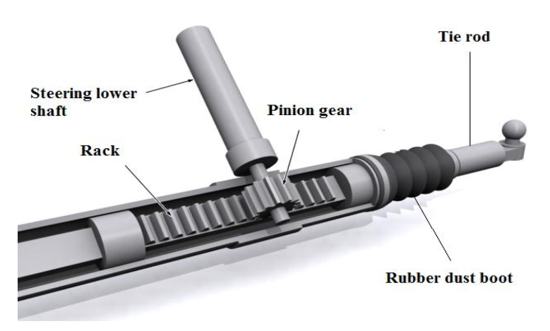

Figure 2.2.1.2: Steering gear schematic

This mechanical linkage between the steering box and the wheels usually conforms to the required condition. When the vehicle is moving very slowly, there is a kinematic condition between the inner and outer wheels that allows them to turn slip-free. It is called as Ackerman condition and expressed by:

**(*)**

where is the steer angle of the inner wheel, is the steer angle of the outer wheel, The distance between the steer axes of the steerable wheels is called the

track and is shown by . The distance between the front and real axles is called the wheelbase and is shown by . Track w and wheelbase are considered as kinematic width and length of the vehicle. Ackerman steering geometry is the term used to describe the behavior of the front wheel when the vehicle is driven around a corner. In the corner when the front tires turn, the inner wheels radius is smaller than the outer wheels and that means the steering wheel is needed to generate the wheel angle for the inner wheels which are larger than the outer wheels, otherwise the inner wheel tends to slide over the road. The Ackerman geometry neglects the effect of road on tire, so it is not completely suitable for modern cars. The wheels behavior interface corner turning can be seen in Figure 2.2.1.3

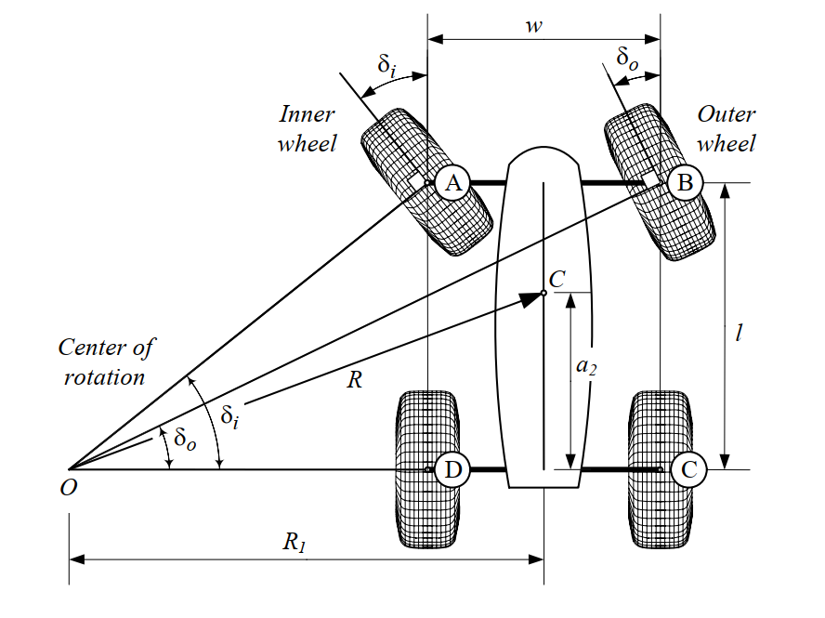

Figure 2.2.1.3: A front-wheel-steering vehicle and steer angles of the inner and

outer wheels.

As can be seen in the Figure 2.2.1.3, the inner wheel angle is larger than the outer wheel, when the vehicle turns around a circle.

It is important to notice that the wheels behavior analysis is a very important point to accurately simulate tire forces. For this reason, all the parameters which can affect the tires must consider in tire modeling.

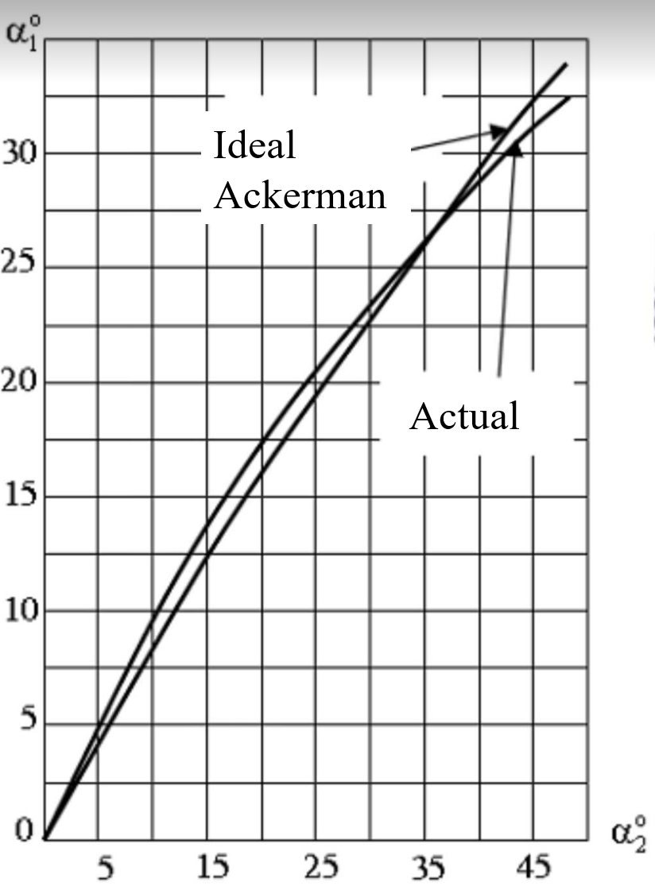

Figure 2.2.1.4: The diagram comparison about the inner and outer angle between actual condition and Ackerman condition

From the Figure 2.2.1.4, we can see that the ideal Ackerman condition and actual inner and outer steering angle have the minimum error only in the range from 0 to 35 degrees. That is the reason why in this project, the steering angle of the wheel is just under 35 degrees

**2.2.2 Wheel angles effects:**

**Caster angle** affects the steering feel by creating a self-centering torque to reduce the toughness of steering. For example, when the caster angle is positive and the wheel is steered, the lateral forces will create a torque around the steering axis and will increase the self-aligning torque of the tire. Increasing of self-aligning torque causes the steering wheel to align quickly. Furthermore, positive caster improves the stability of vehicle in a turn and reduces under-steering situation of the vehicle when the vehicle is exiting from a turn. Positive caster angle will increase handling of the vehicle when the vehicle is turning but it causes the steering wheel to be tougher to move. When the caster angle is negative the lateral forces will produce a torque that helps steering. (Figure 2.2.2)

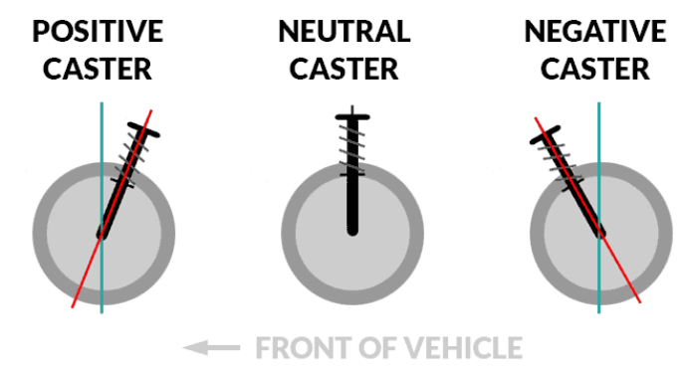

Figure 2.2.2: Overall in Caster angle

**Kingpin angle** has the effects which is usually discussed in terms of the scrub radius offset which determines the value of the self-aligning torque when the wheels are turned. For the zero-scrub radius, no reaction will transmit to the steering wheel and the driver is not able to perceive the change of the vehicle lateral offset. In case of the positive scrub radius (many conventional cars have a positive scrub radius offset) the wheels are returned to the straight position quickly. In case of the negative scrub radius (some modern cars have a negative scrub radius offset) the longitudinal forces will generate a torque that increases the steering of the wheels in a longitudinal direction. For this reason, the vehicle becomes more oversteering when the scrub radius offset is negative, thus the driver is not able to sense the self-aligning torque effect correctly. (Figure 2.2.2.1)

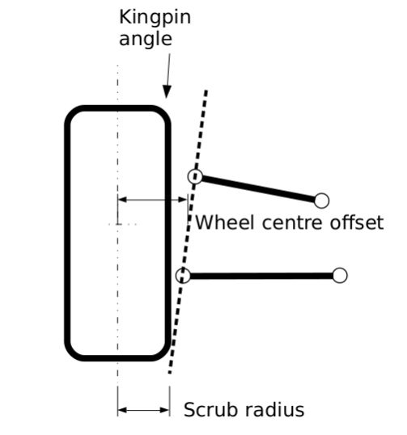

Figure 2.2.2.1: Kingpin angle and its scrub radius

**Camber angle** is the tilting angle of tire about the longitudinal x-axis. Figure 2.2.2.2 illustrates a front view of a cambered tire and generated camber force . Camber angle is assumed positive γ > 0, when it is in the positive direction of the x-axis, measured from the z-axis to the tire. A positive camber angle generates a camber force along the −y-axis. Itis directly influence on the magnitude of the lateral force which the most important factor in vehicle’s steering.

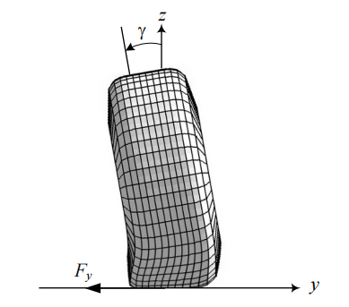

Figure 2.2.2.2: A front view of a cambered tire and the generated camber force.

In this project, only Kingpin angle and Caster angle will be considered for the aligning moment which is going to be mentioned in the next part.

**III/ Vehicle Steering Dynamics and Electric Power Steering dynamic equation:**

**3.1)** **Mathematical modelling of steering system:**

**3.1.1) Mathematical modelling of tire force:**

* **Normal force :** has an influence on a lateral displacement between the contact point of the point of application of this force and the centre plane of the wheel. In this project, the driving situation is the vehicle speed is constant that means we have no acceleration for the normal force calculation. The Electric Power Steering system in this project is set up for the front wheel drive, so the equation of each front tire is:

While:

: the normal force (N)

m: mass of the vehicle (kg)

g = 9.8 (m/: gravitational acceleration

the distance from the center of vehicle mass to rear axle respectively (m)

* **Lateral force** : when a turning tire is under a vertical force and a lateral force , its path of motion makes an angle α with respect to the tire plane. Basically, this force is the friction force to the centrifugal force. The angle is called side-slip angle and is proportional to the lateral force:

While:

Lateral force (N)

: Cornering stiffness of the tire (N/rad)

side-slip angle (rad or degree)

At the maximum lateral force, the wheel will start sliding laterally and its value will be calculated by:

While:

Lateral force (N)

: Normal force at the contact point of the tire and the road surface (N)

: Lateral friction coefficient

The slip angle α always increases by increasing the lateral force Fy. However, the sliding line moves toward the tail at first and then moves forward by increasing the lateral force Fy. Slip angle α and lateral force Fy work as action and reaction. A lateral force generates a slip angle, and a slip angle generates a lateral force. Hence, we can steer the tires of a car to make a slip angle and produce a lateral force to turn the car. In this project, the lateral force is only considered by the effects of the sideslip angle and cornering stiffness of the tire.

* **Longitudinal force** : The longitudinal forces are generated between tire and road, due to the difference in velocity between road and tire, when accelerating and braking. The force Fx is proportional to the normal force:

While:

Longitudinal force (N)

: Normal force at the contact point of the tire and the road surface (N)

: Longitudinal friction coefficient.

One of the most important factors that effects the magnitude of the longitudinal force is longitudinal slip ratio . This slip ratio illustrates the difference between the rotational speed of tire and vehicle longitudinal speed. The slip rate can be calculated as follows:

While:

the rotational speed of tire (rpm)

radius of tire (inch)

vehicle speed (m/s)

Increasing the slip of tire causes increasing of force as well, on the other hand the longitudinal force is gengerated mostly depending on the construction of tire, the road condition and the vertical force applied on the tire. The main reason of force increasing is that the thread element of tire will be deformed and create the longitudinal force. The slip has linear relation with force for low slip rates, so the slope of this curve is called longitudinal tire stiffness. The longitudinal force decreases because the thread elements become saturated and unable to generate more force and the tire is locked in this condition such as Figure 3.1.1 illustrates below.

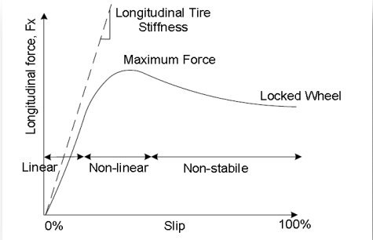

Figure 3.1.1: Longitudinal forces vs slip in the tire coordinate system

**3.1.2) Mathematical modelling of tire moments:**

In the modeling of the steering wheel feedback torque, aligning torque will be considered from the three forces of forces and wheel alignment. They are described as follows:

**3.1.2.1. Aligning moment by longitudinal force:**

These forces create a torque in the tire when the vehicle accelerates or brakes. The created torque in the tire due to a longitudinal force is the product of the longitudinal forces and the moment arm. The moment arm in this case is the scrub radius caused by the longitudinal forces effect, which would be sensed in the steering wheel. The total torque generated around the steering axis by can be calculated starting from Figure 3.1.2

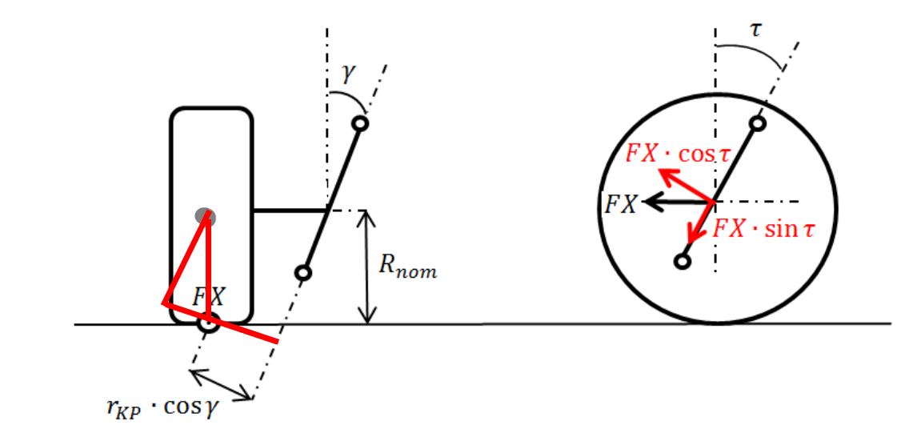

Figure 3.1.2: Scheme used to calculate the resistant torque generated by FX

As Figure 3.1.2 shows the total resistant torque generated around the steering axis due to FX can be computed from:

**(1)**

While:

aligning torque caused by longitudinal force (N.m)

Longitudinal force (N)

Caster angle (degree)

Kingpin angle (degree)

normal scrub radius of the Kingpin angle (m)

tire radius (m)

**3.1.2.2. Aligning moment by lateral force:**

* **Only Caster angle:**
* Self-aligning moment in the case of pneumatic trail:

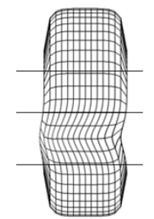 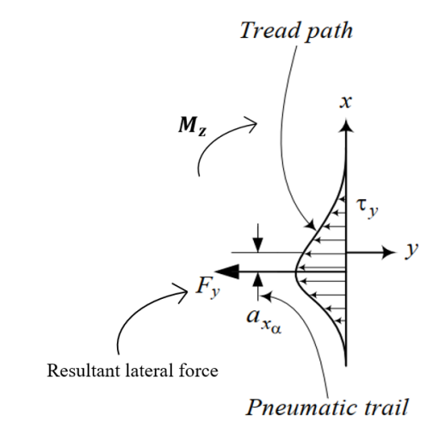

Figure 3.1.2.1: Tire print deflection and aligning moment with pneumatic trail

Figure 3.1.2.1 shows that pneumatic trail is a measure of how a tire's footprint or contact patch changes as it rolls. Pneumatic trail is caused by the progressive build-up of lateral force along the length of the contact patch, such that lateral forces are greater towards the rear of the contact patch (though less so when the rear of the contact patch begins sliding).

Pneumatic trail explains how tires can help you keep your stability and control while you drive. This effect occurs regardless of the steered direction of the tires and can result in a surf-like sensation that occurs when traveling at higher speeds. This force develops and is applied to the length of the contact patch with the rear of the contact patch experiencing the greatest pressure force. This lateral force causes the tire to rotate somewhat, which results in physical force known as self-aligning torque.

**(2)**

While:

: Aligning moment caused by pneumatic trail (N.m)

Resultant lateral force (N)

Pneumatic trail (m)

* Self-aligning moment in the case of mechanical trail:

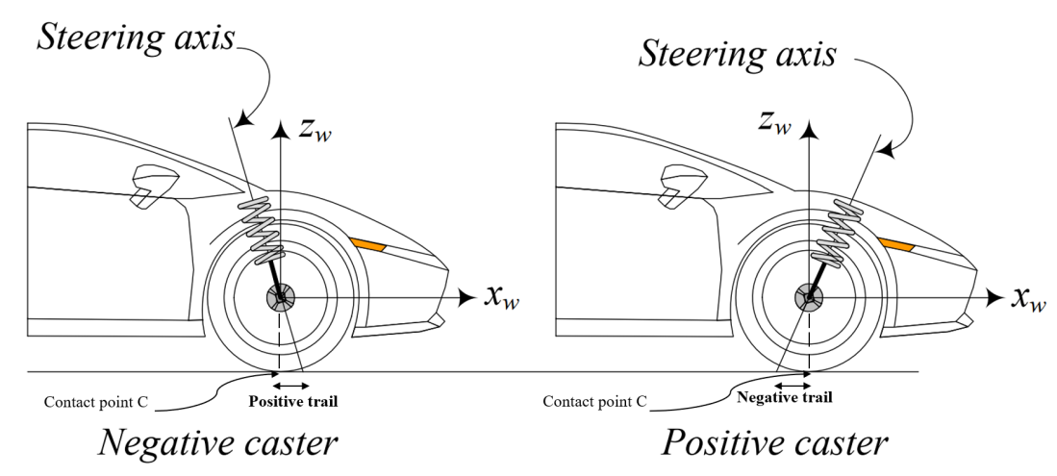

Figure 3.1.2.2: A positive and negative caster on front wheel of a car

Mechanical trail is the horizontal distance between the point where the steering axis of the front wheel intersects the ground and the point where the front tire contacts the ground which is show in Figure 3.1.2.2. In this sense, the contact patch of the tire “trails” behind the steering axis. The greater this distance, the “higher” the trail and the lower the distance the “lower” the trail. This factor also decides how much caster angle can affect on the steering feeling and how returnability of the vehicle through the aligning moment

**(3)**

While:

Aligning moment caused by mechanical trail (N.m)

Lateral force (N)

Mechanical trail (m)

As we can see in the Figure 3.1.2.3, since the trail is positive, friction force F generates a moment that tends to align the front wheel. The straightening moment is proportional to the value of the normal trail. Small positive trail values generate small aligning moments of the lateral friction force. Higher value of the trail (obtained with high value of the caster angle). If the value of the trail were negative (the contact point in front of the intersection point of the steering head axis with the road plane) and considering that friction force F is always in the opposite direction of the velocity of slippage, a moment around the steering head axis that would tend to increase the rotation to the left would be generated

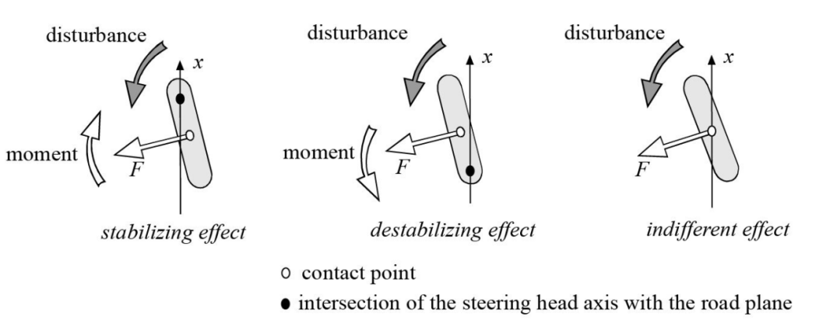

Figure 3.1.2.3: Summary of the effect of trail during forward movement

* Self-aligning moment in the collaboration of both trails

This moment tends to turn the tire about the z-axis and make the x-axis align with the velocity vector v. The aligning moment always tends to reduce α. It calculated by the equation:

**(4)**

While:

Aligning moment (N.m)

Aligning moment caused by pneumatic trail (N.m)

Aligning moment caused by mechanical trail (N.m)

Lateral force (N)

Pneumatic trail (m)

Mechanical trail (m)

As we can see in above equation, the self-aligning moment depend on the lateral force and the magnitude of the total trail (the sum of mechanical and pneumatic trail).

* **Kingpin and Caster angle collaboration:**

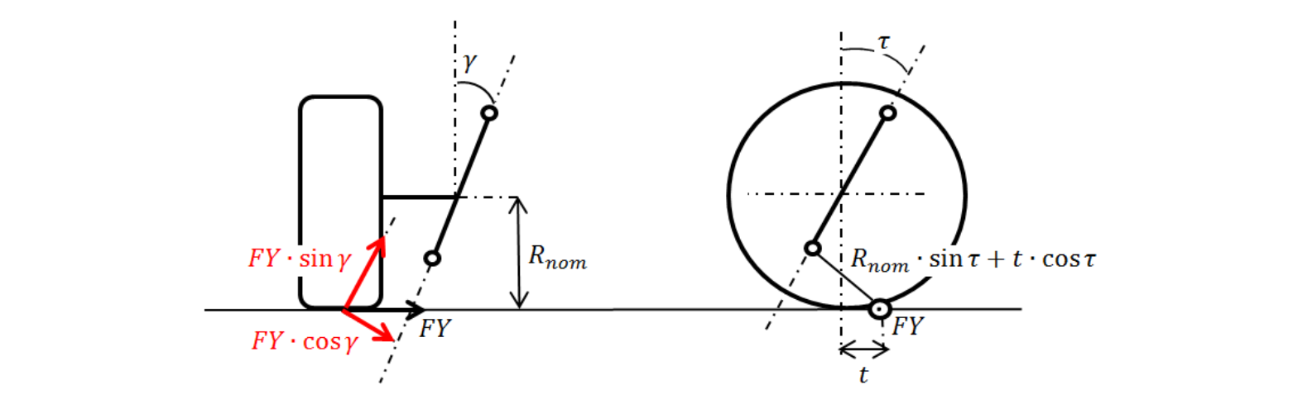

Figure 3.1.2.4: Scheme used to calculate the resistant torque generated by Fy

Figure 3.1.2.4 shows the the caster and KPI effect on the lateral forces of tire. So, the generated torque due to FY around the steering axis can be determined from:

**(5)**

While:

aligning torque caused by lateral force (N.m)

Lateral force (N)

Caster angle (degree)

Kingpin angle (degree)

normal scrub radius of the Kingpin angle (m)

tire radius (m)

**3.1.2.3. Aligning moment by normal force:**

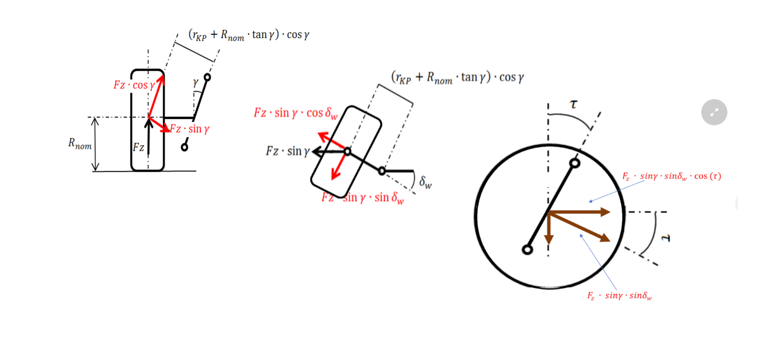

Figure 3.1.3: Scheme used to calculate the resistant torque generated by Fz

The torque produced due to can be calculated from:

**(6)**

While:

aligning torque caused by normal force (N.m)

Normal force (N)

Caster angle (degree)

Kingpin angle (degree)

normal scrub radius of the Kingpin angle (m)

tire radius (m)

steering angle (degree)

* From the section **3.1.2.1, 3.1.2.2, 3.1.2.3,** the total resistant torque generated around the left and right tires of the front steering axis can be calculated as:

**(7)**

While are the left and right front wheel respectively.

In this project, the aligning torque will be only considered by the effect of the caster angle and kingpin angle (as mentioned in function **(5)**) on the tire model. The steering system model considered is based on the torques and forces and is presented in Figure 3.1.3.1.

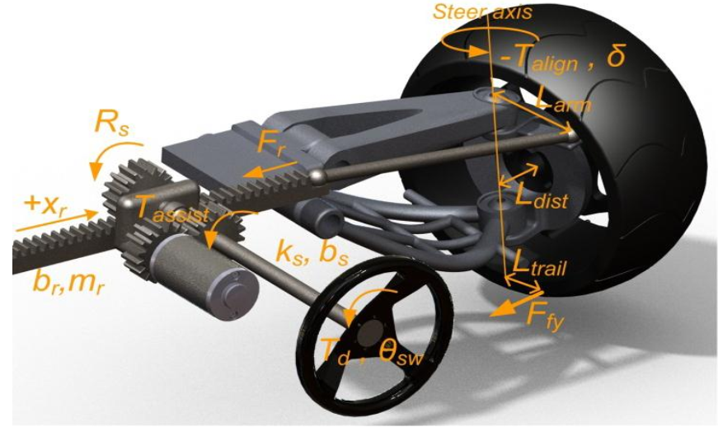

Figure 3.1.3.1: Mathematical scheme of steering system

As the Figure 3.1.3.1 illustrates, the resist forces on the rack can be calculated from as:

**(8)**

Where: is the resist force on the rack

: is the aligning torque that the tire effect on the steering system (N.m)

is the moment arm (m)

**3.2)** **Electric Power Steering Dynamic equations:**



**Figure 3.2**: The overall Electric Power Steering dynamic factors

**Figure 3.2** illustrates the physical structure of a steering system. The structure components are a column type steering system which include the steering wheel, steering column, the rack and pinion mechanism. The assistance motor is a permanent magnet synchronous motor, connected to the steering shaft through gears and provides the assisting torque needed by the driver to steer the vehicle. The input torque from the steering wheel is measured by a torque sensor mounted on the steering column and connected to the electronic control unit. The assistance torque produced by the motor acts on the wheel via rack and pinion system. Different amount of assistance torque is applied depends on the driving conditions, which is realized with a specific control logic implemented in the ECU.

Using Newton's law and neglecting no necessary factors the equations of EPS can be derived:

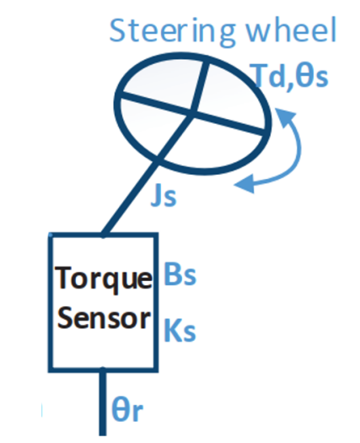

**Figure 3.2.1:** Overall structure of the steering input

* The dynamic equations from the steering wheel to steering column:

**(9)**

While:

Inertia of steering wheel and steering column (kg.

Viscous damping coefficient of steering column (deboost of steering column) (Nm.

Rigidity of torsional bar (Nm.)

Turn angle of steering wheel (rad)

Turn angle of output steering axle (rad)

Input torque of steering wheel (N.m)

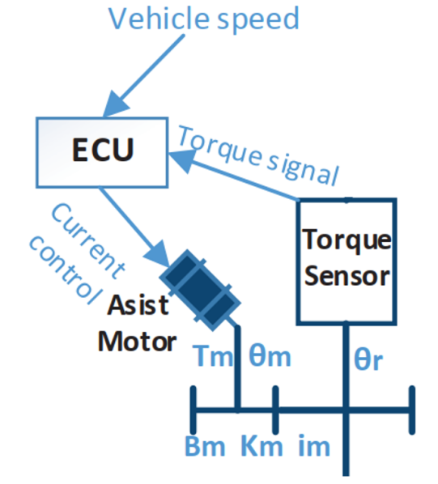

**Figure 3.2.2:** Overall input, output signal and structure of assist motor section

* The dynamics of assistance section, which is showed in Figure 3.2.2, is described by following equation:

**(10)**

While:

the moment of inertia of the motor and clutch section (kg.

Viscous damping coefficient of the motor (deboost of the motor) (Nm.

Rigidity of the motor and reducer (Nm.)

Turn angle of motor (rad)

Turn angle of output steering axle (rad)

Reduction ratio of reducer

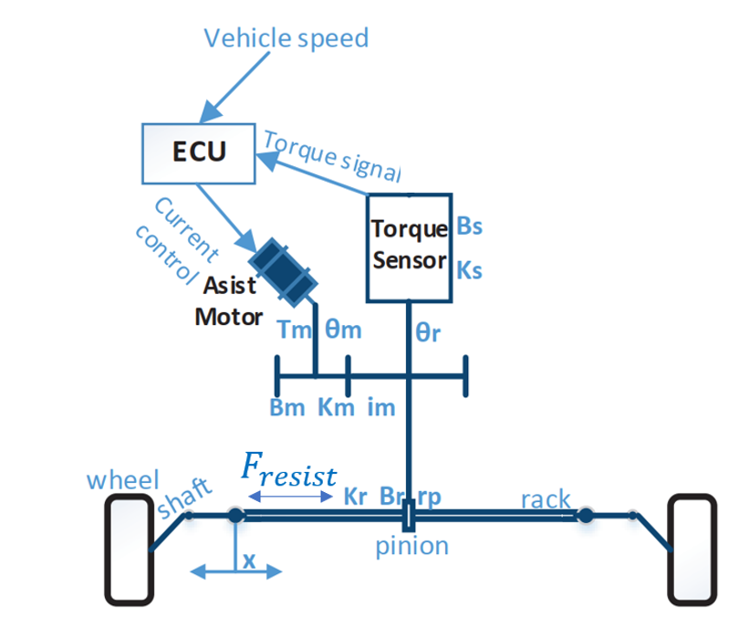

**Figure 3.2.3:** Overall Rack and Pinion Dynamics

* Finally, rack and pinion section is illustrated in Figure 3.2.3 and governed by the equation:

**(11)**

While: the resist force acting on the rack (N)

m: mass of the pinion and rack (kG)

pinion radius (

Viscous damping coefficient of rack and pinion (deboost of the rack and pinion) (Nm

Rigidity of the motor and reducer (Nm)

Turn angle of motor (rad)

Turn angle of output steering axle (rad)

Reduction ratio of reducer

Turn angle of steering wheel (rad)

Rigidity of torsional bar (Nm)

**IV/ Result and Discussion:**

All the parameters will be taken from the table below:

|  |  |  |
| --- | --- | --- |
| Symbols | Value | Name |
|  | 0.0012 [kg] | Inertia of steering wheel and steering column |
|  | 0.26 [Nm] | Viscous damping coefficient of steering column |
|  | 115 [Nm] | Rigidity of torsional bar |
|  | [Rad] | Turn angle of steering wheel |
|  | [Rad] | Turn angle of output steering axle |
|  | [Nm] | Input torque of steering wheel |
|  | [Nm] | Output torque of the motor |
|  | 125 [Nm | Rigidity of the motor and reducer |
|  | [Nm | Viscous damping coefficient of the motor |
|  | 7.225 | Reduction ratio of reducer |
|  | [Rad] | Turn angle of motor |
|  | 91064 [N] | Linear rigidity |
|  | 653.203 [Nm | Viscous damping coefficient of rack and pinion |
|  | 0.0078 [m] | Pinion radius |
| x | m | Rack displacement |
|  | 32 [kG] | Mass of the rack and pinion system |
| m | [kG] | Mass of the vehicle |
|  | [m] | Wheelbase |
|  | 1.684 [m] | Track width |
| g | 9.8 [m | Gravitational acceleration |
|  | 70000 [N] | Cornering stiffness of front axle |
|  | 1.325 [m] | Distance from front axle to center of vehicle |
|  | 1.532 [m] | Distance from rear axle to center of vehicle |
|  | 0.08 [m] | Disturnbance force moment arm |

Table 1: Electric Power Steering Parameters

4.1/ The aligning torque with varying Caster and Kingpin angle

4.2/ The aligning torque with varying in lateral force

* Mass of vehicle (Fy at maximum later force)
* Cornering Stiffness
* Sideslip angle
* Friction coefficient